Open Enrollment Partner Social Media Content

 | Post Content (copy and paste into your social media accounts) | Asset
Partner Post 1 | Find low-cost health plans and opportunities for savings on @VAInsuranceMarketplace.  Start saving today and enroll in a low-cost plan by December 31 for coverage to begin on January 1. Open enrollment ends January 15: marketplace.virginia.gov/new-customers | Download asset file from the Open Enrollment Partner Content folder to include in your post.  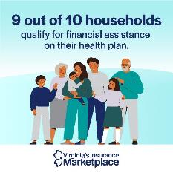  File Name: VIM Partner Social Post 1.jpg
Partner Post 2 | Comprehensive health insurance within your budget. Find low-cost plans and see if you qualify for financial savings with @VAInsuranceMarketplace.  Get insured today. Enroll by December 31 for coverage to begin January 1 and by January 15 for coverage to begin February 1: marketplace.virginia.gov/new-customers | Download asset file from the Open Enrollment Partner Content folder to include in your post.  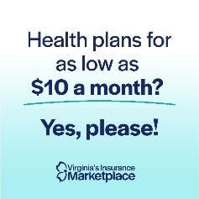  File Name: VIM Partner Social Post 2.jpg
Partner Post 3 | If you’ve lost Medicaid, check @VAInsuranceMarketplace for affordable, high-quality health plans to keep you covered.  Enroll by December 31 for coverage to begin January 1. Open enrollment ends January 15: marketplace.virginia.gov/new-customers | Download asset file from the Open Enrollment Partner Content folder to include in your post.    File Name: VIM Partner Social Post 3.jpg
Partner Post 4 | Coming down with something? Having health insurance helps you feel better.  Prep for flu season and get health insurance on @VAInsuranceMarketplace. Enroll by December 31 for coverage to begin January 1 and by January 15 for coverage to begin February 1: marketplace.virginia.gov/new-customers | Download asset file from the Open Enrollment Partner Content folder to include in your post.    File Name: VIM Partner Social Post 4.mp4

Partner Post 5 | From now until January 15, Virginians can shop for and enroll in health plans on @VAInsuranceMarketplace.  Shop Marketplace plans: marketplace.virginia.gov/new-customers | Download asset file from the Open Enrollment Partner Content folder to include in your post.    Video File Name: VIM Partner Social Post 5.mp4
Partner Post 6 | All plans on @VAInsuranceMarketplace cover essential health benefits like doctor visits, prescriptions, and more.  Enroll in a health plan by December 31 for coverage to begin January 1. Open enrollment ends January 15: marketplace.virginia.gov/new-customers | Download asset file from the Open Enrollment Partner Content folder to include in your post.  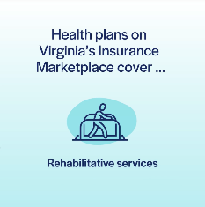  File Name: VIM Partner Social Post 6.mp4

